CEFR Level B2 | Standardisierte Reifeprüfung mündlich (Themenblock 2)

Themenblock 2: SCHOOL & EDUCATION

CATEGORY A: CONTRASTING IMAGES

TASK SET A1: Learning Environments
PART 1 — Individual Long Turn
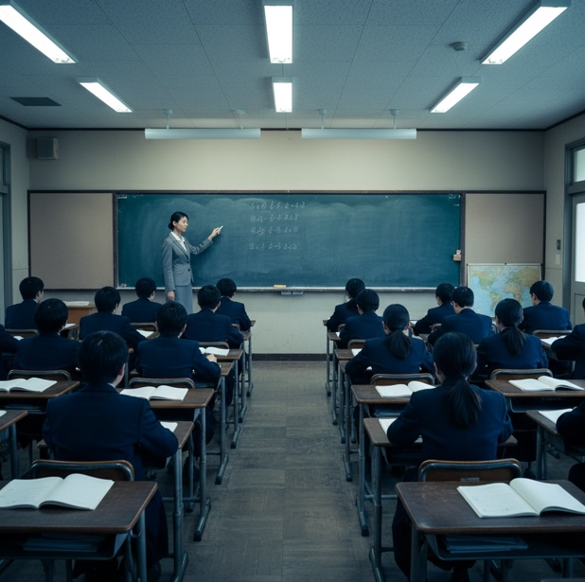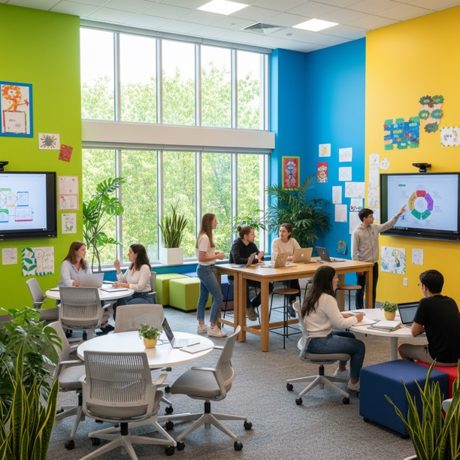
Task:
Give a five-minute talk on learning environments in which you
- describe, compare and contrast the two classroom settings shown in the pictures above.
- analyze how the physical environment might affect student learning and motivation.
- discuss whether schools should prioritize investing in modern learning spaces.
PART 2 — Paired Activity
Task:
Your school has received a grant of €50,000 to improve learning environments. You and your partner are on the student committee that will advise on how to spend the money. Discuss the following options and agree on two priorities:
- Creating flexible seating areas in classrooms
- Installing interactive whiteboards and screens
- Building outdoor learning spaces
- Creating quiet study pods for individual work
- Renovating the library into a modern learning hub

TASK SET A2: Learning Approaches
PART 1 — Individual Long Turn
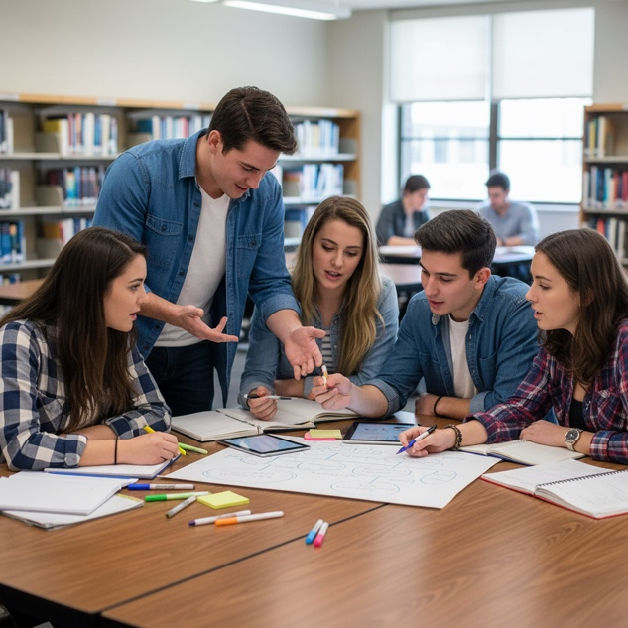
Task:
Give a five-minute talk on learning approaches in which you
- describe, compare and contrast the two learning situations shown in the pictures.
- evaluate the advantages and disadvantages of individual and group study.
- comment on which approach works better for you personally and why.
PART 2 — Paired Activity
Task:
Your school wants to improve exam preparation support. The student council has been asked to recommend study programs. Discuss the following programs and rank them from most to least beneficial:
- Peer tutoring sessions (students helping students)
- Teacher-led revision workshops
- Online self-study platforms with practice tests
- Study groups facilitated by older students
- Silent study halls with teacher supervision

TASK SET A3: Learning Methods
PART 1 — Individual Long Turn
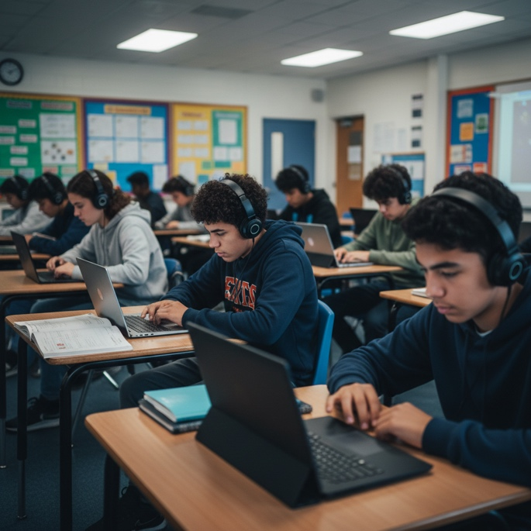
Task:
Give a five-minute talk on learning methods in which you
- describe, compare and contrast the two learning situations shown in the pictures.
- analyze the benefits and limitations of digital learning compared to hands-on experiential learning.
- discuss how schools can best combine technology with practical, real-world learning experiences.
PART 2 — Paired Activity
Task:
Your school is developing a new curriculum that balances digital and hands-on learning. The principal has asked for student input on how to integrate both approaches effectively. Discuss the following approaches and agree on three to prioritize:
- Virtual reality field trips and simulations for subjects like history and geography
- Maker spaces with 3D printers, robotics kits, and craft materials
- Blended learning with online theory modules followed by practical lab sessions
- School garden and environmental projects connected to biology and ecology curriculum
- Internship programs and real-world work experience placements

CATEGORY B: QUOTES

TASK SET B1: Education and Assessment
PART 1 — Individual Long Turn
Quote 1:
"Education is the most powerful weapon which you can use to change the world."
— Nelson Mandela, speech at Madison Park High School, Boston, 23 June 1990
Quote 2:
"That is why assessment is, indeed, the bridge between teaching and learning."
— Dylan Wiliam, Embedded Formative Assessment (2011)
Task:
Give a five-minute talk on education and assessment in which you
- critically analyze the two perspectives on education and assessment expressed in the quotes above.
- evaluate the role of assessment in helping students learn and achieve their potential.
- suggest how schools could use assessment more effectively to support learning.
PART 2 — Paired Activity
Task:
Your school is reviewing its assessment policy. The administration wants student input on how grades should be determined. Discuss how much weight each component should carry and agree on a percentage split:
- Written exams and tests
- Class participation and engagement
- Project work and presentations
- Homework and assignments
- Peer and self-assessment

TASK SET B2: Purpose of Education
PART 1 — Individual Long Turn
Quote 1:
"The roots of education are bitter, but the fruit is sweet."
— Aristotle, as recorded in Diogenes Laertius, Lives of Philosophers (3rd century CE)
Quote 2:
"The function of education is to teach one to think intensively and to think critically. Intelligence plus character — that is the goal of true education."
— Martin Luther King Jr., "The Purpose of Education," Morehouse College student newspaper, 1947
Task:
Give a five-minute talk on the purpose of education in which you
- explain and compare the different views on education expressed in the two quotes.
- discuss whether schools should prioritize academics or character development.
- outline what you consider the most important goals of education in the 21st century.
PART 2 — Paired Activity
Task:
A local newspaper has asked students to contribute to a feature about "The Ideal School of the Future." You and your partner need to write a short article together. Discuss which aspects to include and agree on three main points for your article:
- Personalized learning paths based on individual strengths
- Strong focus on mental health and wellbeing
- Real-world problem-solving and community projects
- Global connections through technology and exchanges
- Preparation for careers that don't yet exist

CATEGORY C: ALTERNATIVE PROMPTS

TASK SET C1: International Education Systems
PART 1 — Individual Long Turn
Text Extract:
Finland's education system consistently ranks among the world's best in PISA assessments, yet Finnish students spend fewer hours in school than their peers in most other countries. There are no standardized tests until age 16, homework is minimal, and recess time is generous. Meanwhile, South Korean students typically spend 12 to 16 hours a day focused on education, including after-school academies called 'hagwons.' Both countries perform well academically, raising questions about what truly makes an education system successful.
— Adapted from OECD Education at a Glance reports and PISA data
Task:
Give a five-minute talk on international education systems in which you
- analyze the contrasting approaches to education described in the text extract.
- discuss what factors might contribute to a successful education system beyond academic results.
- evaluate what aspects of other countries' education systems Austria could learn from.
PART 2 — Paired Activity
Task:
The Austrian Ministry of Education is seeking student input on potential reforms. You and your partner have been invited to a focus group. Discuss the following proposed changes and agree on two that would be most beneficial:
- Later school start times (beginning at 9:00 AM)
- Longer break times between lessons
- More project-based learning instead of traditional subjects
- Reducing homework and increasing in-class practice time
- Adding life skills courses (financial literacy, cooking, etc.)

TASK SET C2: Student Wellbeing and Pressure
PART 1 — Individual Long Turn
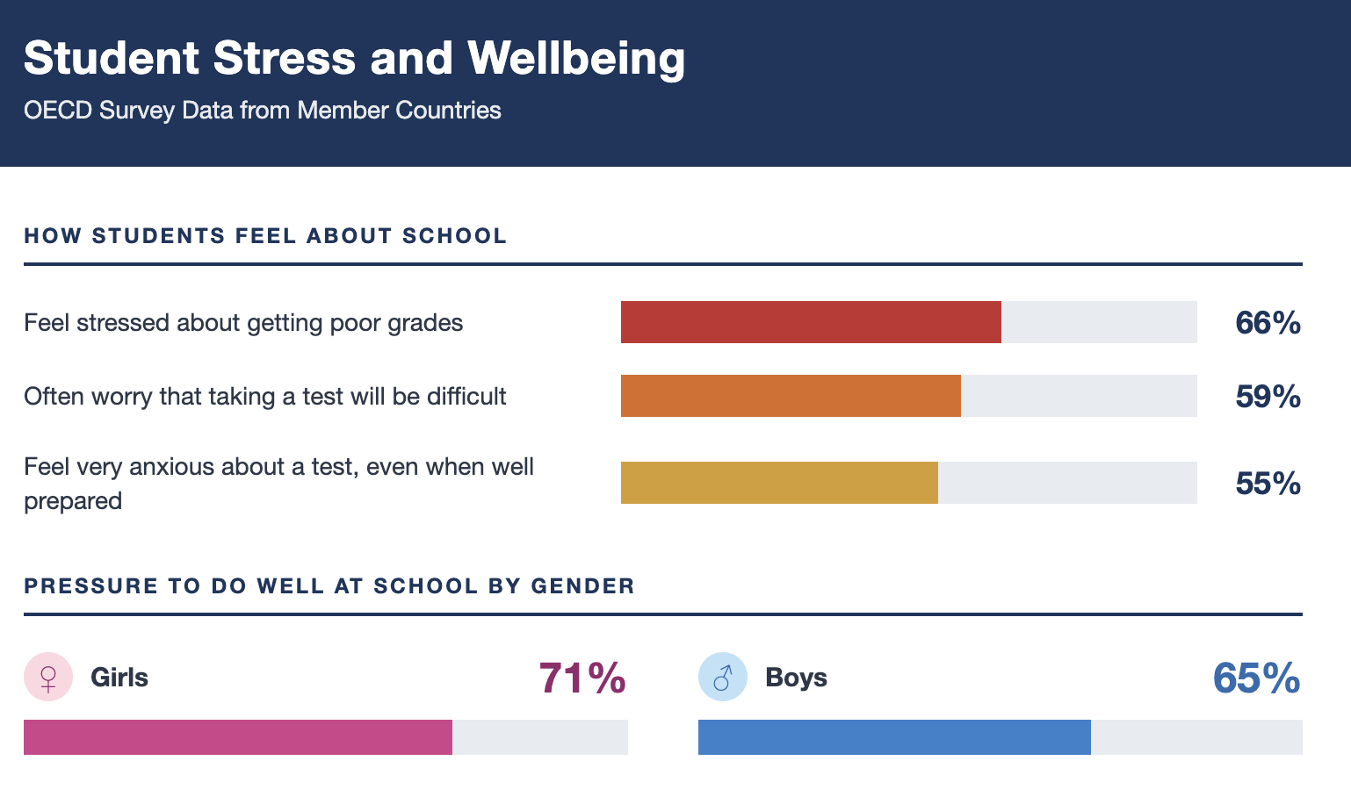
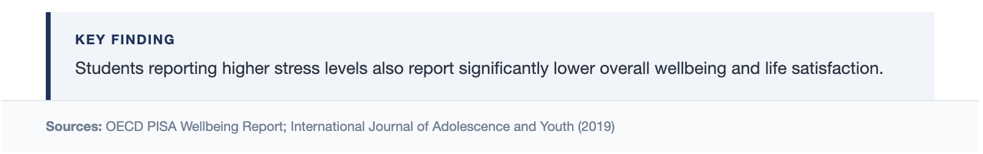
Task:
Give a five-minute talk on student wellbeing in which you
- analyze the statistics presented and what they reveal about student experiences today.
- discuss the main sources of stress for students and how schools could address them.
- suggest strategies students can use to manage academic pressure and maintain their wellbeing.
PART 2 — Paired Activity
Task:
Your school is creating a "Student Wellbeing Week" to address mental health and stress. You and your partner are helping to plan the program. Discuss the following activities and agree on three to include in the week's program:
- Workshops on study techniques and time management
- Relaxation sessions (yoga, meditation, breathing exercises)
- Panel discussion with psychologists about coping strategies
- Sports and outdoor activities day
- Creative expression workshops (art, music, drama therapy)

